Newton’s Second Law
Newton’s second law of motion explains the relationship among force, mass, and acceleration. In this activity, you will study the relationship between acceleration and mass, while keeping force constant. A car carrying different masses will be pulled across a table by a hanging weight—the constant force. Acceleration will be measured using a computer-interfaced Motion Detector. You will plot a graph of acceleration versus mass, and then use the graph as you make conclusions about the relationship between mass and acceleration.

OBJECTIVES
In this experiment, you will
- Use a computer-interfaced Motion Detector to determine acceleration.
- Record data.
- Graph data.
- Make conclusions about the relationship between mass and acceleration.

MATERIALS
computer | paper cup
Vernier computer interface | meter stick
Vernier Motion Detector | sand
Logger Pro | 3 masses
car with card attached | balance
masking tape | plastic tape
string

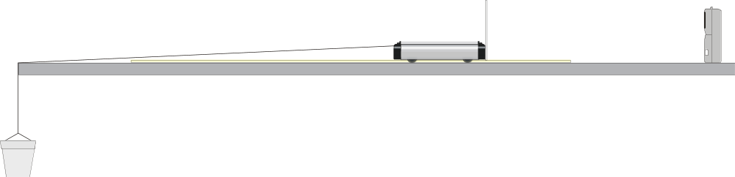
Figure 1

PROCEDURE
1. Tape a card to the back of a car as shown in Figure 1. Mass the car and 3 supplied masses and record these values in your data table (to the nearest 0.10 kg).
2. Attach a cup to a string. The cup will hang over the edge of the table as shown in Figure 1. Attach the other end of the string to the car.
3. Tape a meter stick to the table top to act as a guide for the car. Use two pieces of tape, one at each end of the meter stick. The car should straddle the meter stick. To reduce friction, attach plastic tape at the place where the string passes over the table edge.
4. Connect the Motion Detector to the DIG/SONIC 1 channel on the interface. Fasten the Motion Detector in line with the meter stick and at least 45 cm behind the car in its starting position. Always start the car from the same place.
5. Put enough sand in the cup to pull the car and 3 masses across the table. Determine and record the mass of the cup and sand.
6. Prepare the computer for data collection by opening the file “39 Newtons 2nd Law” from the Physical Science w Vernier folder.
7. Place your car at the starting position. Click  and release the car after you hear a sound coming from the Motion Detector. Catch the car before it goes over the table edge.
8. Determine the mean acceleration of the car.
- Use the Start and End markings on Figures 2 and 3 to help you identify the region of the Acceleration vs. Time graph where the car was moving across the table.
- Select this region by holding the mouse button down as you drag a box around it.
- Click the Statistics button, 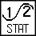.
- Record the mean acceleration.

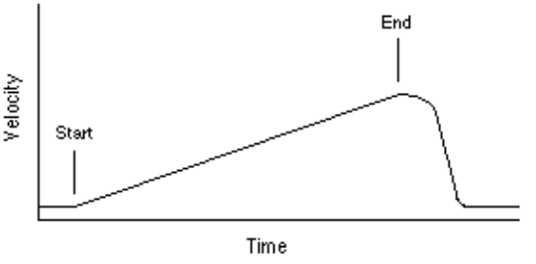
Figure 2

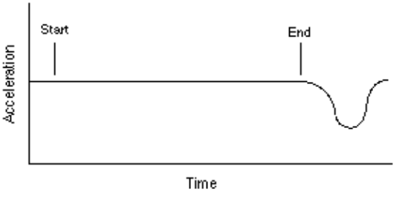
Figure 3

9. Repeat Steps 7 and 8 two more times. Be sure to start the car from the same place each time.
10. Remove Mass #3 from the car, but do not change the amount of sand in the cup. Repeat Steps 7–9.
11. Remove Mass #2 from the car and repeat Steps 7–9.
12. Remove Mass #1 from the car and repeat Steps 7–9.
13. Print graph for your last trial. You will use this graph as you answer Question 5 of Processing the Data.
14. Add masses and record total mass for each of the four combinations in the Data and Calculations Table.
15. For each of the four combinations, calculate the average acceleration for its three trials. Record the results in the Data and Calculations Table.

DATA AND CALCULATIONS
Mass (kg)

Car Mass #1 Mass #2 Mass #3 Cup + Sand
Mass (kg) _______ _______ _______ _______ _______

Acceleration (m/s²)

Trial 1 Trial 2 Trial 3
Car, cup, sand plus masses 1, 2, and 3 _______ _______ _______
Car, cup, sand plus masses 1 and 2 _______ _______ _______
Car, cup, sand plus mass 1 _______ _______ _______
Car, cup, and sand only _______ _______ _______

Total Mass Avg. Acceleration
(kg) (m/s²)
Car, cup, sand plus masses 1, 2, and 3 _______ _______
Car, cup, sand plus masses 1 and 2 _______ _______
Car, cup, sand plus mass 1 _______ _______
Car, cup, and sand only _______ _______

PROCESSING THE DATA
1. Add masses and record total mass for each of the four combinations in the Data and Calculations table.

2. For each of the four combinations, calculate the average acceleration for its three trials. Record the results in the Data and Calculations table.

3. Graph the data on Page 2 of the experiment file. Plot TOTAL MASS (in kg) on the horizontal axis and AVERAGE ACCELERATION (in m/s2) on the vertical axis.

4. What is the relationship between mass and acceleration?

5 Does this agree with what you have read about Newton’s second law of motion? Explain.

6. Which is easier to accelerate, a sports car or a moving van? Why?

EXTENSION
1. What will happen to acceleration if you increase the amount of sand in the cup? Design an experiment to test your answer.

